{FIRST NAME} {LAST NAME}
{ADDRESS 1}
{ADDRESS 2}
{CITY}, ON
{POSTAL CODE}
{DATE}
{NAME} –

Since the last election, grassroots Liberals across Ontario have been hard at work rebuilding our party and showing the people of this province that they have a real choice in 2022.

We know the upcoming campaign will be our greatest challenge yet. Right now, the Ford Conservatives are working to cancel the government funding we introduced to help political parties transition to small-donor political fundraising.

We knew that we had to get big money out of politics and put our democracy back in the hands of the people of this province. But that also means that every dollar we spend to win the next campaign will come from someone like you.

{FirstName}, if we want to win the next election, supporters like me and you will have to give – our time, our skills, and yes, our hard-earned money.

The easiest way to make a meaningful, ongoing contribution to our election victory is by becoming a monthly donor to our new campaign fund, the Liberal Future Fund.

Become a donor today by visiting
ontarioliberal.ca/donate/future-fund

The Liberal Future Fund is a new monthly giving program built to directly benefit our local riding association while electing a new Liberal government.

Through the Fund, you can make a donation of $5 or more to our local association and $5 or more to the Ontario Liberal Party – the total amount is completely up to you.

Donating is easy with automatic withdrawals that you can set and forget in the lead up to the campaign. Then, every month, your donation will go directly towards electing a Liberal MPP in our community and a Liberal Government at Queen’s Park.

Here in our own community of {NAME}, monthly donations made through the Liberal Future Fund are already helping to {insert content about work of local riding}.

All of this hard work has been made possible by generous supporters who continue to invest in our local association each and every month as we get closer and closer to the next election.

{FirstName}, there’s no easier way help build toward victory in our community between now and the election. Help us build a Liberal Future for Ontario – join us today by becoming a monthly donor.

Sincerely,

{SENDER NAME}
{ROLE}
{NAME} Provincial Liberal Association

PS. Your donation is eligible for generous provincial political tax credits. Here’s a look at how much you could save on your donation this year:

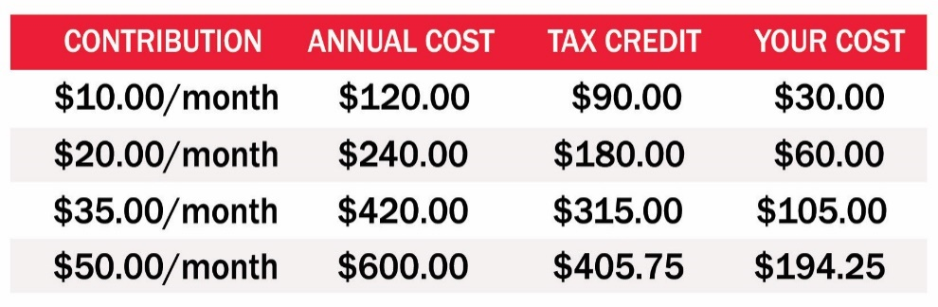

PPS. A donation of $35 per month will cost you just $8.75 after generous provincial political tax credits. That’s less than the cost of streaming Netflix every month!

Learn more at ontarioliberal.ca/LiberalFutureFund OR
Start your donation now at ontarioliberal.ca/donate/FutureFund

