Setting up a Virtual Phone Bank
Reaching out to people in your riding by phone is a great way to interact with your community while maintaining safe conditions for everyone. This guide will go over how to set up a Virtual Phone Bank that volunteers can use from home.
- Creating your List of People to Call
  - Create the list of people that you want to reach out to. This can include your Registered Liberals, donors, or past volunteers on the Shared Contacts side of the database or you can also choose to reach out to the entire riding on the My Voters side of the database.
  - Householding:
    - If your volunteers could collect responses from any member of the households they reach, make sure to narrow your list to one person per household. This avoids unnecessarily calling the same household multiple times in the same phone bank.
    - If you want responses from everyone on your list, but not from other members of their households, don’t narrow your list to one person per household.
- Send your List to the Virtual Phone Bank tool
  - From the My List page, click on the Calls icon.
  - Then, click on Set up Virtual Phone Bank List.
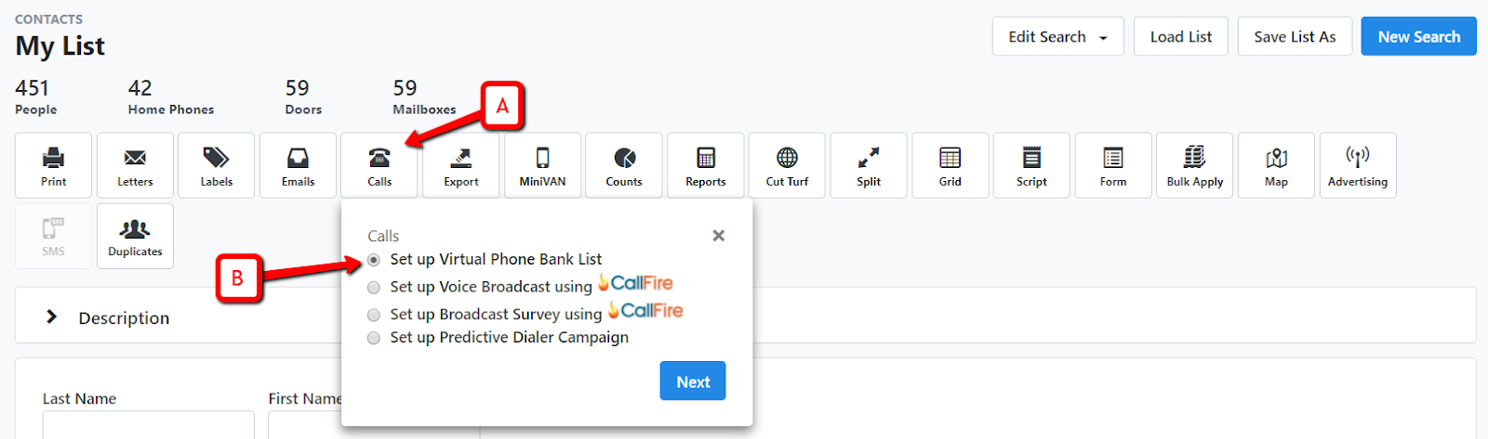
  - Select a Saved Search, this will be a dynamic list that changes according to the criteria you selected. This allows you to refresh your phone bank to add or remove people based on your list criteria. It’s much easier than creating a new phone bank! Then,click on Continue.
  - Click Continue
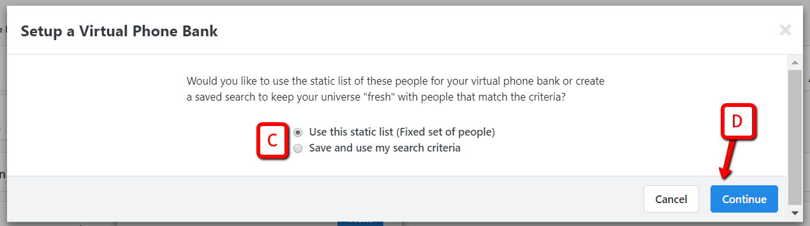
- Enter the Virtual Phone Bank Details
  - Begin by giving your VPB a name.
  - You may also add a description that includes the criteria of the list that you are using to make your calls. This will make it easier to remember what the phone bank was about when looking at it later.
  - Select the appropriate Script from the drop-down box.
  - Enter the dates that you want your phone bank to be live.
  - Select a Sharing Option
    - Within the VPB, you have two sharing options, select Not Visible on openvpb.com.
  - Choose whether or not to add the Event Scheduler to your VPB
You can choose to allow your callers to schedule the people they contact for an event, presumably an online event like an info session or tele-town hall, given the circumstances, directly through the VPB.
    - Tick the box next to the Event Scheduler. Additional fields will appear.
    - Enter the date range of the events that you want to be able to schedule people for. Please note these dates need to be within a week.
    - Select the Event Types that you want to be able to schedule volunteers for.
    - Under Event Role, select Attendee/participant. This will ensure that all individuals that want to attend this event are marked as Attendee/participant.
    - In Event Status, select Scheduled. This will ensure all interested individuals get marked as scheduled.

- Set your Additional Settings
Many of these settings are optional but can be very helpful for running a VPB.
  - Daily Availability: Set this field to times that fall within the hours permitted by CRTC regulations. This field ensures that your callers are only making calls within a certain time frame. It’s essential to enter times here for home phone banks. Your callers are phoning from home so you can’t easily see when they’re phoning. Your callers might accidentally call early in the morning or late at night, which is against the rules and really annoys your contacts.
  - Time Limit: You can set a time limit for your phone bank which regulates the amount of time your callers can spend making phone calls. This is helpful to prompt your volunteers to take a break if they have been making calls for a long time. It is a good practice to set this to 60 minutes.
  - Contact Limit: This feature will set a goal for your volunteers to reach in terms of successful contacts or attempts. Used in conjunction with the Progress bar function, this feature can be used to encourage your volunteers to reach a set number of attempted calls or successful attempts. We strongly suggest that you use Attempts rather than Contacts, as this rewards volunteers for calling even if not a lot of people are picking up our calls.
  - Repeat: If setting a time limit or a contact limit, it is important to tick the Repeat checkbox. This will allow your callers to repeat a session so that they can continue making phone calls. Otherwise, they’re locked out!
  - Distribute Contacts: Enabling this function will prompt your callers to enter their postal code when logging into the phone bank. They are then first served the individuals who live closest to them. This is a great idea during a remote phone bank because your callers will be prompted to call people that live near them first, garnering more of a sense of community.
  - Householding: Householding is tricky but important.
    - If you want each person in the household to get a call, regardless of whether they live with a person on your list who has already been called, choose Do not display Also in Household. This means that you won’t see any of the people who live with the person you’re calling, so they each get their own call. A household with 4 people on your list would get 4 calls. It’s not our favourite option.
    - If you want an answer from each person on your list but want to be able to canvass a whole household in one call whenever possible, choose Show only People in Household from Virtual Phone Bank list. This is perfect for projects like Membership Renewal where you need to ask every member to renew their membership, but don’t want to talk to people who live in the house who are not on your list (they may already be renewed or may not be members).
    - If you don’t need an answer from everyone in the house and don’t mind who you talk to in the house, choose Show all Also in Household.
  - Alternate Numbers: Select Attempt Alternate Numbers. The system will display all alternate phone numbers that we have in the database for the person you are trying to reach. This helps you to clean up your phone numbers as you go.
  - Skipping: Skipping allows your callers to skip a household or contact so that they do not have to make that call if they feel uncomfortable doing so. We recommend you pick this option. Volunteers will be more comfortable and your data will be more accurate.
  - Status: Set the status to Active!
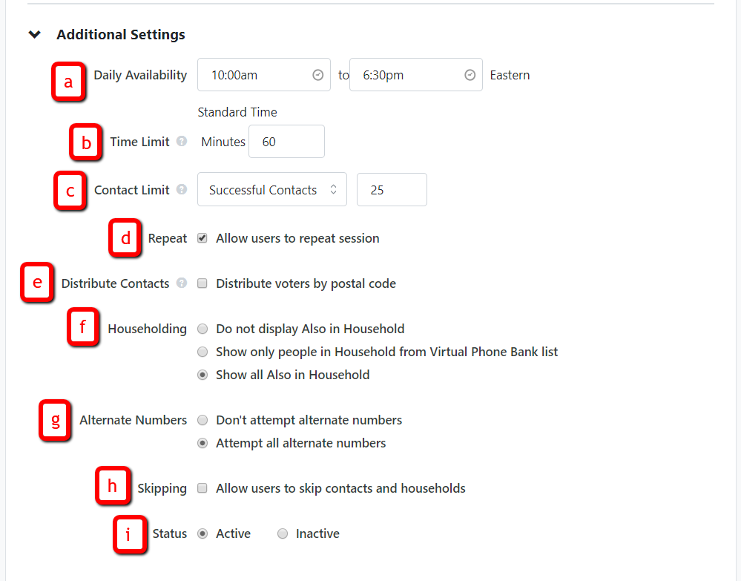

- Enabling Display Settings
Displaying certain information is really useful to your callers, but displaying too much can be overwhelming. It is strongly recommended that you display the following settings:
- Age and Sex: This will give your caller a better idea of who they are reaching out to.
- Preferred email and preferred phone: This will allow your callers to see what email we have on file and what an individual’s preferred phone number is set as. It is always a good idea to display these settings so you can confirm that these are good ways to reach them. For example, if you offer to send someone contact information for community groups that can help them, you should confirm that you have the right email address for them.
- In the Editable Contact Section, make Phones and Emails editable. This will allow your callers to make edits to that information while on the phone with a voter. Keeping this information up to date is crucial!
- Displaying Survey Questions and Activist Codes: These are not necessary and can influence your callers’ impressions of their conversations. The setting displays data points that allow your caller to see their support in previous elections or any issues they care strongly about.
- When creating a phone bank on the My Voters side of the database it is especially discouraged to display past Survey Questions and Activist Codes because they can display affiliation information which could bias a caller or make them uncomfortable making the call.
- Progress Bar: This is a great feature that allows your callers to see how well they are progressing through their Virtual Phone Bank. You can choose to include an individual progress bar and a progress bar for the entire team.
  - If you had set a Contact Limit, the individual progress bar will show how well a volunteer is progressing towards their contact limit. This encourages your volunteer as they make calls! This is a great feature to use for a remote phone bank!
  - If your phone bank list is very large, avoid choosing to make the entire phone bank progress bar visible to callers. It’s a little scary to have so many calls to make! If your list is smaller, the progress bar is encouraging to volunteers making calls. They can see how well you are progressing as a team!

- Create your Phone Bank!
- Scroll up to the top of the page and click on Next once all your criteria has been selected.
- Your phone bank is now created and your settings were saved for next time!

- Sharing your Phone Bank
You have various options to share your VPB:
- Share your VPB by providing your volunteers with the List number generated. This should be included in the email that you send to your volunteers on the day of the VPB to ensure that they can get connected.
- Share your VPB by scrolling down to the User Access Section. Highlight the names of the users you want to give access to and click Add. They will become Users with Access. You should share the VPB with all the people that confirmed that they will make calls for you on the day of the VPB.
- Share your VPB by scrolling down to the Committee Access Section and click on your riding committee. Click Add so that all of the users in your committee gain access to the VPB.
We recommend that you either add the specific volunteers or the whole committee as well as share the List number so that you make it really easy for your volunteer to access the phonebank!

