Monitoring a remote phone bank
Phone banks can be especially tricky when the callers are not all together in one room. As people practice social distancing and make calls from the comfort of their own homes, it will be important to keep an eye on the calls that are being made to ensure that everyone is getting the most out of the experience.
Using built-in reporting tools will help you to determine how well your team is progressing through their phone calls and to identify trends in the data that you are collecting. These trends can identify your superstar volunteers, your callers that are struggling, and give you an overall sense of how many people are being successfully contacted.
- Begin on either the Shared Contacts or My Voters side of the database, depending on where your Virtual Phone Bank was created.
  - If you are reaching out to members, donors, volunteers or other stakeholders, make sure you are on the Shared Contacts tab.
  - If you are contacting voters, make sure you are on the My Voters tab.
- Find your Virtual Phone Bank
  - From the Administrative Menu in the left-hand column, open the Phone Services
  - Click Virtual Phone Bank.
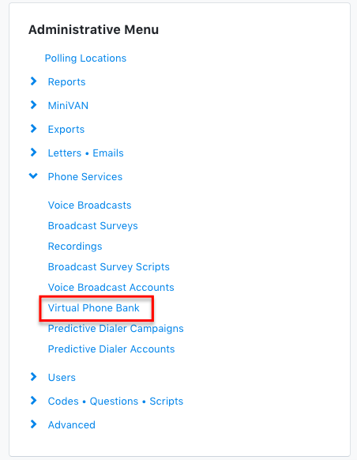
- Click Report beside the name of the phone bank for which you want to view the results.

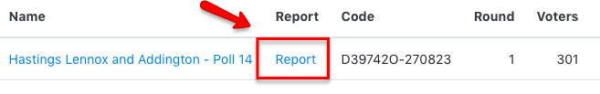
- The report for your Virtual Phone Bank will show the results both with Total Attempts and sorted by all Canvassers who have made at least one call.
  - Above the report, you may change your report’s settings to view All attempts or Canvassed only, narrow a date range to view your VPB results for certain dates, or tick in the box to view percentages for your Canvass Results.

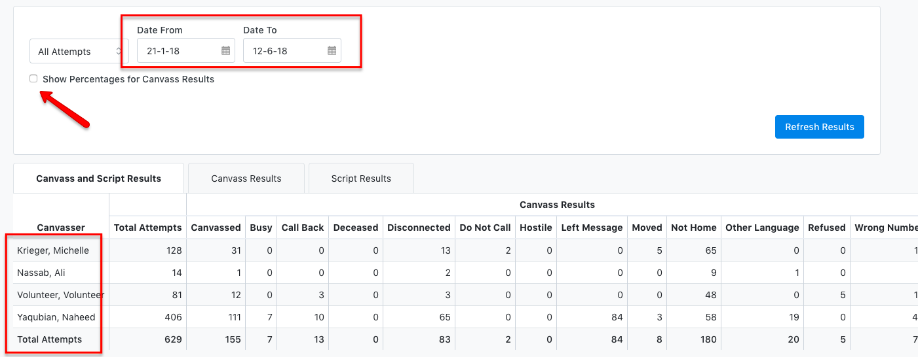

- Tabs are available above, which you may press to view your results based on Canvassed Results or Script Results.
  - Canvassed Results focuses on the outcomes of calls, whether callers had a conversation (canvassed), they weren’t able to reach someone (e.g. Not home or Disconnected), or they weren’t able to complete the script when they did reach someone (e.g. Wrong number, Refused).
  - Script Results shows the responses your team inputted from the canvassing script. All categories available in the script will be listed under Script Results.

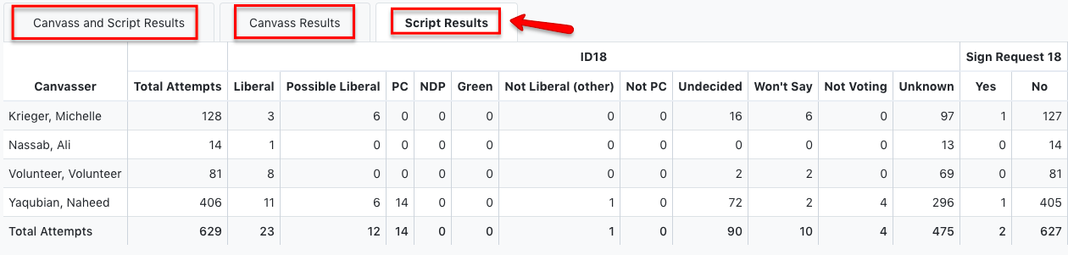

These reports allow you to assess how individual volunteers are doing. For example, if any volunteers are recording a higher number of refusals, they may sound uncomfortable or unfriendly when speaking to voters. They may need additional support and training. You may also be able to identify that one volunteer has a high number of negative responses, this may be due to various reasons that can be worked out by speaking to the volunteer.

Contacts who did not answer the script and have been entered as any category other than Canvassed in Canvassed Results and will appear under Unknown in Script Results.

Tips and Tricks:
You may notice a difference between the “Attempted” number shown on the Administrative panel and the “Total Attempts” number shown in the VPB Report. If you're calling alternate numbers, which is best practice, the VPB tracks calls to these numbers as "Attempts". The "Attempted" is how many people who we attempted to contact. So if you call three numbers for the same person, the system counts that as 3 attempts but 1 person attempted. You only attempted to contact 1 person, but attempted them 3 times.
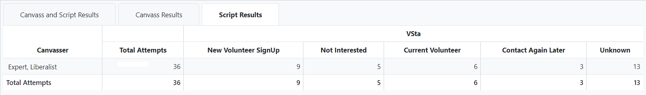
Keep an eye open for the following:
- How many people have you been able to contact successfully?
  - Is this number very low (under 5%)? Maybe you aren’t calling at the best time of day or the best day of the week.
- Contact rate by caller
  - Is there a volunteer that is making an incredible amount of calls? Acknowledge your volunteer’s great work! Starting a Leaderboard is always a great way to encourage effort.
- High refusal rates?
  - Is one particular volunteer getting a high rate of refusals? If so, they may not be approaching the call in the best way and require further training. Try going over the script with this volunteer to determine best practices!
- High positive rates?
  - A volunteer who has a much higher percentage of positive responses than the rest of the team may benefit from additional support as well. They might need to have the reponses better explained to them or may need to have a better sense of what the responses will be used for. It’s useful to explain that the goal of the project is not to collect the most positive results, but to check in with the community and record the results of these conversations for future use.
  - Avoid celebrating high counts of positive responses and focus on attempts. This will keep your results more accurate.

