Getting Connected: How to Log in

Methods of getting connected

At the main login screen, you will notice that there are two ways to log into the database. Option 1 allows you to log in using your ActionID OR option 2 allows you to log in using your VANID.

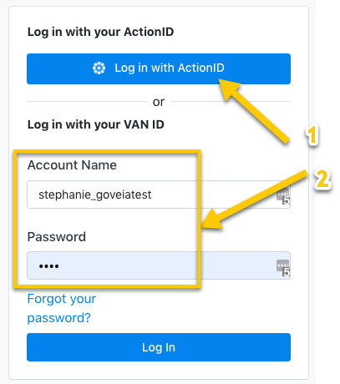

Logging in using Action ID:

1. Click on **Log in with ActionID**

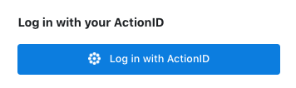

1. Enter your Email Address and Password

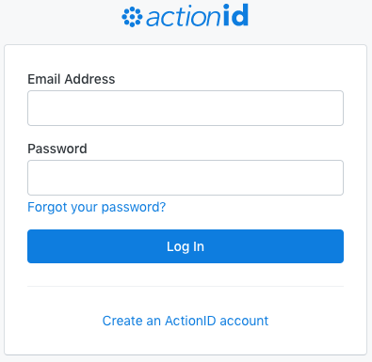

1. Click on **Log In**

Logging in using VAN ID

1. Enter your Account Name and Password

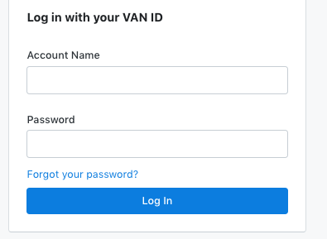

1. Click on **Login**

Resetting a forgotten password:

Click on **Forgotten your password?**, enter your email and you’ll be able to make a new one from a reset link in your email inbox.

|  |  |  |
| --- | --- | --- |
|  | ActionID | VAN ID |
| What’s needed to login? | Email and password | Username and password |
| Do I need to remember my username? | No need to remember a username - just use your email! | Must remember username |