Create a Script
It is important to determine the goals for the phone bank before you get started and then write your script to achieve those goals. You may want to add a datapoint to your script to record how your contact is feeling about the current situation, or include information in the script for your callers linking them to groups who are helping community members struggling during this difficult time.
1. Start on the My Voters or Shared Contacts side of the database
- This depends on whether you are reaching out to members and donors or your list of electors.
2. Click on Codes • Questions • Scripts in the Administrative Menu and then click Scripts. Here, you will be able to view and manage all your custom scripts.
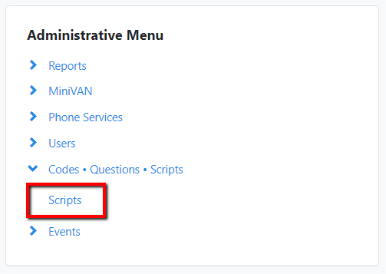
3. Click Add New Script in the upper right hand corner.
4. Give your script a name and description.
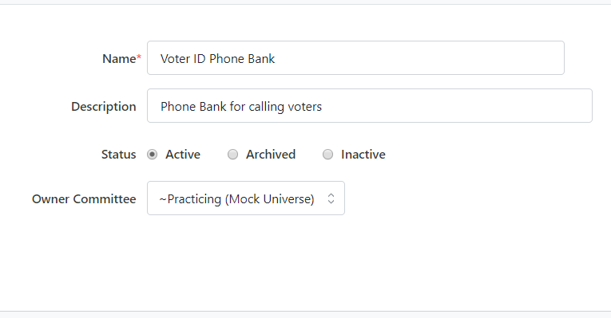
5. Under Add Script Element, you’ll have different options available to personalize your script. Your script should help your volunteers to talk to people in a way that fits this tough moment we’re facing globally. Don’t forget to add opportunities to express empathy and comfort.
- Begin building the script by inserting the different script elements and positioning them within the script by dragging the ‘five-lines’ icon beside the element you wish to move.
- You can also edit each section or delete it.
- Make sure to always click the Save button to save the order of your sections.
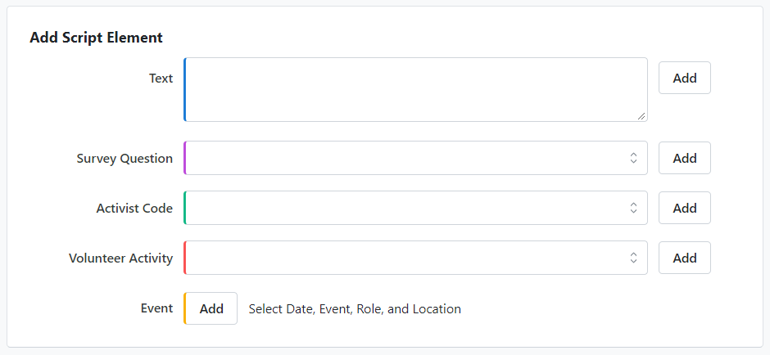
6. To add a text element, simply write in the text you would like to provide for canvassing. Click Add.
- Your script should give opportunities for people to share their concerns, but do make sure you avoid stating or implying that your team will provide tangible and immediate help unless you’re ready to provide it. You don’t want to risk disappointing someone who believes some type of assistance, be it groceries or regular social engagement, is on its way.
- If you would like to edit a text field, you can always click Edit to go back to a particular section and modify it.
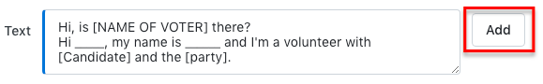
7. To add a question, select the Survey Question you would like to use during the canvass from the drop down menu under Survey Questions. Click Add.
- We recommend adding the Volunteer Status survey question to the script, even if it’s just at the bottom for data recording purposes and not part of what you’re asking volunteers to say. Some of the people you call may appreciate the outreach so much that they want to join your team.
8. To add an Activist Code, select the Activist Code you would like to use during the canvass from the drop down menu under Activist Codes. Click Add.
9. To add an event, click Add and select the date and name of your event. This will likely not be necessary for this type of engagement call.
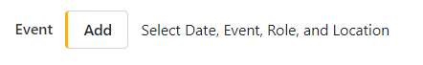
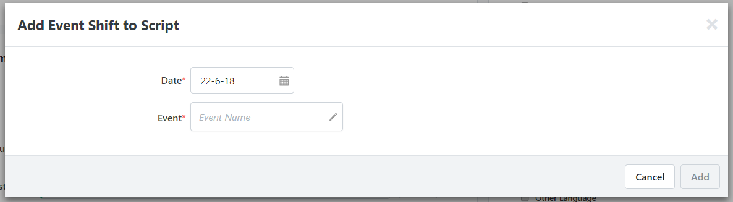
10. Select the different walk / phone results that you would like to make available as responses on your script. Only select the additional Phone / Walk results that you think your volunteers will need in order to successfully track results of their canvass. Your canvasser will be able to select the responses you choose from any canvassing sheet or Virtual Phone Bank that uses this script.
It is best practice to always include Do Not Call in your script whether it will be used for phoning or doorknocking. If a doorknocking script is used for a phone bank you want to make sure your volunteers are able to select Do Not Call. CRTC Regulations state that you have to make it easy for your volunteers to add people to the your campaign’s Internal Do Not Call list.
For phoning, we suggest that you also select “Busy”, “Refused”, “Wrong Number”, “Disconnected” and “Deceased”, as well as any other Phone Results that suit your project.

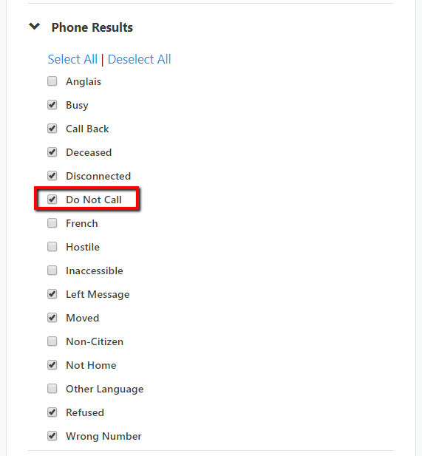
10. Choose the electoral district(s)/committee(s) that can have access to your script by using the add and remove buttons. If you have only been granted access to one Liberalist committee, you will be able to share your script with only that committee. If you have access to more than one Liberalist committee, the names of all of your committees will appear and you may select which committee you want to give access to the script.
