Getting Connected: Accessing the Phone Bank

Reaching out to your riding’s contacts by phone is an effective means to communicate while making sure to respect physical distancing practices. You can have meaningful conversations with people on the phone to check-in on them and see how they are doing
- Start by making sure you're on the right side of the database.
  - Connect to the Shared Contacts if you’re calling donors, members or volunteers.
  - Connect to My Voters if you’re reaching out to constituents or to your community in general.
  - Still unsure? Ask whoever coordinated with you to make calls!
- Select the Virtual Phone Bank icon.
  - Hint: It’s located on the bottom right corner of your menu!
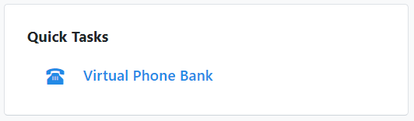
- Access your VPB
  - If a VPB has been shared with you, you will see the name of the VPB appear at the top. Otherwise, enter the VPB code that has been shared with you. Press Next.
  - Note: If ever you don’t see the VPB or the code doesn’t work, make sure to try the other side of the database!
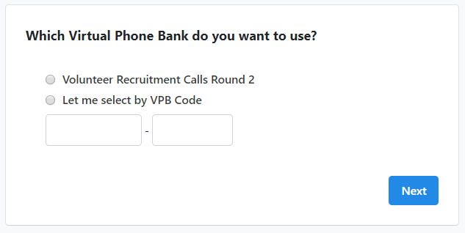
The Interface of the VPB
- The Progress bar
At the top of the page, you may see the progress bar. This can display either the entire phone bank progress or your personal progress. You will see the bar go up as you and your team make phone calls.
- Household Members
Here you may be able to see all the individuals at the household that you are calling.
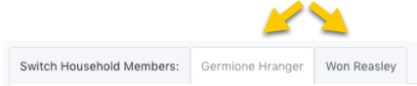
- Your Contact
The name of the first person in the household will be the one displayed below. Ensure that you select the correct household member when entering data in the script. Before you go to your next call, make sure you indicate that I Couldn’t Reach (First Name) for all persons in the household you couldn’t reach so that the whole household is taken off your call list.
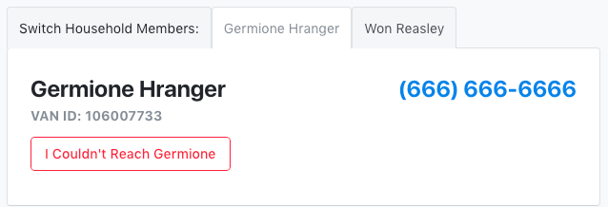
- The Script
The script is included below for easy reference, but do familiarize yourself with the script before starting your phone calls! This will make you sound more confident on the phone.
- Additional Info:
You may be able to view additional information for the contact such as another phone number or email address. Some of the additional information may also be modifiable depending on the way the coordinator set up the phone bank. This will allow you to make changes to the data in the system.
- Making your calls!
The VPB will show you the first person on your list, including their name and phone number. It will also show you the script you should use when calling and the options you have for editing the information in each person’s profile (eg. their address). Familiarize yourself with your script and your options before you pick up the phone.
- Pick up the phone! Dial the number of the first person on your list and use your script to complete the call.
- Enter the appropriate canvass results in the script as you are speaking to the individual on the phone. Simply go through the script while clicking on the drop-down menu to apply the appropriate responses to the Survey Questions or tick the box next to an Activist Code that applies to your conversation.
- Once you have entered the information from your call, make sure to click Save/Next so the information is saved in the person’s profile and you can make your next call.
- ***IMPORTANT*** You have to enter a call result or a scripted answer for every person you talk to. If you do not enter any information for a person you have called, they will STAY on the list and someone will call them again.
- If you cannot reach the person, click on the box that says I Couldn’t Reach X and mark down why you were unable to speak to that person

